2)How to edit and run code in chrome
go to source in chrome dev tolls. there are various ways we can write code in chrome dev tools. go to snippets. then have new snippet, name it main.jss. so we will write our js code in this file. how we execute it. press play button on right hand side.
3)what is "use strict" and what does it do
it allows you to place a function or program in whats called strict operating context. we will see what it is. it makes debugging easier. code errors which otherwise would have been ignored or would have failed silently will now generate errors and exceptions.this alerts you about errors in your code and directs you quickly to probable source. so how do we turn it on-
"use strict";
write this on top of your js file. why string , this is because when it was launched all browsers dnt supported it. if use strict was keyword then they would have given error. so we came up with "use strict".
there is another method which is used in legacy codes-
// Not strict mode..
function newCode(){
"use strict";
//strict mode
}
here we are writing some code in strict mode and some in non strict code.
why use strict mode?
1)using a variable before it is defined , causes error.
code-
sumit ="sood";
console.log(widow.sumit);
if we dnt use strict mode then first statement would create a property named sumit on global object(in browser it is called window) and code will work fine.
what is problem with it? code-
var theVal =0;
theVl =1;
if(theVal >0){
}
if we dnt use this mode then it will be very hard to debugg this code.but if we use strict mode then it will give us error that theVl is noot declared. so it makes easier to debug our code.it tells us upfront that this is syntax error in my application, so we dnt have to spend hours on debugging it.

2) it stops us from using keywors that are reserved for future versions of java script
ex-
var let =1;
let is used in ES6.
3)you cannot delete functions,varibale or function arguments in strict mode.
ex-
var foo = 1;
delete foo;
function moo(){};
delete moo;

4) it makes makes evel safe to use.
in non-strict mode-
var eval = 1;
this is fine but in strict mode it will error.
strict mode also makes act of calling eval a bit safer. eval lets you evaluate a js expresion by passing string. it lets you evaluate arbitary bits of javaScript code.
in non-strict mode, a is declared as global varibale and this works fine-
eval("var a =1");
console.log(a);
in strict mode-
"use strict"
var a =2;
eval("var a =1");
console.log(a);
a= 2 is printed.
in strict mode the variables that we declare inside eval code remains inside eval mode and dnt leak out. if we dnt decalre a outside eval then it will, say a is not declared.
eval is powerful feature of js, so you should treat it with respect.

5) In strict mode, default this dnt point to global object . it points to undefined.it prevents us from potentially making a mistake

4)does java script pass varibales by refrence or by value
it means how variable are passed to functions. Answer is-
Primitive data types are passed by value and objects are passed by refrence.
objects are passed by refrence to function. we can only add or change properties on this object . we cnt make it point to new object. ex-
This is fine
var sumit = {};
function f1(obj)
{
obj.sood ="surname";
}
f1(sumit);

This not fine-
var sumit = {};
function f1(obj){
obj ={ prop1: "js"}
}
f1(sumit);
this change wnt reflect outside the function. so we can change a property of object or we can add a property. we cnt change to what that object points to.

}

5)what are difrent types in js
primitive types- number,string, boolean,undefined,null
non-primitive type - object.
note - if we use typeof operator on null, it returns object. this is incorrect.it is bug in java.
d/w between a dynamically typed language like js and statically typed language like Java
it means in js type of varibale is determined at run time. same variable can be number,string, boolena at duffrent time. it depends upon type of value that we assign to this variable.
Null vs Undefined
null means variable dnt has any value. Undefined means it may have value but we dnt know it yet.
Undefined is used-
1)when we decalre a variable its type is undefined.
var a;
console.log(a);
2)if we dnt pass parameter in function calling, then value of that paraemeter is null.
function f1(a){
console.log(a);
}
f1();

3) when we try to acess a property on object that is not defined. we get null.

other important diffrence is that, only programmer sets a variable equal to null, js cnt do that. js engine can set a variable to undefined.
null == undefined
it gives true.
But if we do null === undefined, we get false.

7)what is NaN and how can we check for it?
it stands for not a number. it happens when we do some calculation on something that is not a number-
abc/4
its type is number.
some properties of nan-
1) NaN compared with anything is false. even if we compare it with itself it well then also returns false(NaN === NaN). so we have special function in js, that checks it.-
isNaN(1)- returns true or false. but this function has its own problems-
Nan("A") - returns true. it is beacuse js converts string A into numbers. so its becomes NaN. so what ever value we give to isNaN function, it will try to convert it into number and then check it.
isNaN("1") - false. This is because "1" is converted into 1. if want to see how a value is convert into number-
Number("1")
similarly for string-
String(1).
so what is way to makr sure that value is Nan.
var a =NaN;
a !== a
if it returns true, it means it is NaN. because NaN is only value that is not equal to itself.
this is very important concept.
9)Variable Hoisting
Hoisting is a JavaScript mechanism where variables and function declarations are moved to the top of their scope before code execution.
It is automatic hoisting of variable decalaration to the top of its enclosing scope.
Ex-
console.log(a);
var a=1;
because of function hoisting this code is equivalent to –
var a;
console.log(a);
a=1;

Output is – undefined.

same is true of functions also. It takes functon declaraion and moves it to top of its enclosing scope.

Ex-
foo();
function foo(){
var a;
console.log(a);
a=1;
}
Because of function hoisting, this is equivalent to this code-
function foo(){
var a;
console.log(a);
a=1;
}
foo();
however hoisting does not work for function expressions. Ex-

foo();
var foo =function{
var a;
console.log(a);
a=1;
}
Because of hoisting this code is converted to-
var foo;
foo();
foo =function{
var a;
console.log(a);
a=1;
}
Output-
Error-foo is not a function.
Error is because java script knows that foo is variable but it does know that this variable is a function. So we get a error.
Order of precedence in hoisting

It's important to keep a few things in mind when declaring JavaScript functions and variables.
- Variable assignment takes precedence over function declaration
- Function declarations take precedence over variable declarations
Function declarations are hoisted over variable declarations but not over variable assignments.

10)What is scope chain
we have 2 types of scopes- global and functional. lets say we have a inner function inside our function. then if we try to read some variable in inner function, then it looks into scope chain. first it will search for that variable in inner function scope, if it cnt find it in there, then it will go to outer function. if it is not found even there then it will continue to go outer and outer until it reaches global scope. then it is called scope chain. this is how js resolves a variable.
Scope chain is defined by the way the program is written in the file.
function foo(){
console.log(myvar);
}
function goo() {
var myvar = 1;
foo();
}
goo();

here we get the error that myvar is not defined. reason for this is scope chain is defined lexically.it means scope chain is defined in the order in which code is written on file.so myvar is not avalible to foo bcoz myvar is not defined above foo function(global scope).
variable are resolved in order on which code is written on page.however if we define foo inside goo then it will print myvar. it first looks for this varibale in scope of foo, it dnt find it, then it moves to scope of goo, there it finds it. Ex-
function goo() {
var myvar = 1;
function foo() {
console.log(myvar);
}
foo();
}

goo();

12)What are function closures
According to scope rules when a functions exits , any variable declared in that function go out of scope and are deleted.one exception for that is with closures.
When ever function returns a functions, a functions that is returned keeps a refrence to any variables that it needs to execute.like in our example it keeps the refrence to text variable. We can see these closure in chrome dev tools. See image below.
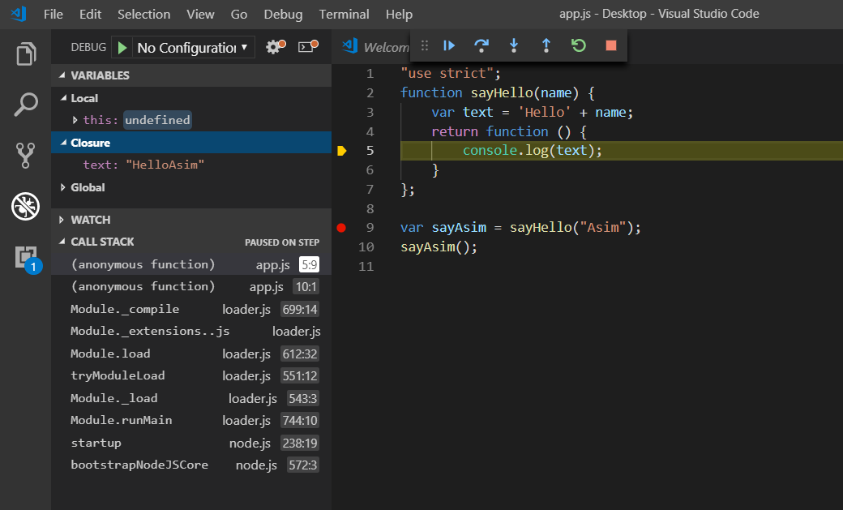
In scope we have local, global and closure field. So inner functions first looks inside its local scope for text variable, it wnt find it. then it looks for text variable in closure, here it finds it. If it dnt find it in closure then it will look for it in global scope.
This is what closure is. It is special set of refrences to variables that a function needs in order to execute , variable that are out of this function scope.
"use strict";
function sayHello(name) {
var text = 'Hello' + name;
return function () {
console.log(text);
}
};

var sayAsim = sayHello("Asim");
sayAsim();

output -
Hello Asim
closure can be very complex, but there are couple of things that you need to know about them-
1)they can refer to variables in outer scope, in scopes external to itself(scope of function). In our example, since a function is returned by sayHello ,it is going to be closure. So it can refer to variable in scopes outside of itself in outer scope. Like its referring to text variable, which is in outer scope in scope of function sayHello.
2) it can refer to those variable, variable in outer functions even after those outer functions have returned.
But that’s the basic knowledge. Interview will ask something like this-
var foo = [];
for (var i = 0; i < 10; i++) {
foo[i] = function () {
return i;
};
}
console.log(foo[0]());
console.log(foo[1]());
console.log(foo[2]());

output-
10
10
10
here in order to work, our function requires variable i, which is global scope(outer scope). So its again creating a closure. For this function to work, it requires i variable(which is in outer scope).
Output is it because when closure are created they did’nt get the copy of variable they get a refrence of it. Here i points to actual value of i in outer scope. So by the time we call function, all loops have been exhausted and value of I is 10. So 10 is printed in each call.
So closure points to current value of whatever variable are used in function body.
(However if we use let instead of var, then abooe problem is solved.this something that I found by myself). For more detials-
https://stackoverflow.com/questions/762011/whats-the-difference-between-using-let-and-var-to-declare-a-variable-in-jav
now lets continue with lecture-

So what to do if want different value of I in each function, here we use concept of IIFE –
var foo = [];
for (var i = 0; i < 10; i++) {
(function () {
var y = i;
foo[i] = function () { return y };
})();
}
console.log(foo[0]());
console.log(foo[1]());
console.log(foo[2]());

Here we define a variable in function and return that variable. Now each function has its own scope. So when we call function , we create variable y and assign it whatever value of i was when that function was executed. And then we return y instaed of i in our closure. What happened here-
When we define a function f[i], we know we need to have y in order to execute that function. So it stored the refrence to y variable, internally in its own closure. So even when our IIFE function exited, y variable is not destroyed(because closure has refrence to it). So when we are calling function(foo[i]()), it is getting value of y when that iife was created. That’s neat trick with IIFE that get you round this problem of closures and fact that closures only point to current value of outer scope variables rather than the value of the time when closure was created.
So concept is-
Closure point to current value of outer scope variables rather than the value at the time when closure was created. What we are doing here is we creating a scope, a scope just for this closure, then you basically are snapshoting whatever values you need for that closure at that moment in time.

but there is also a cleaner way of solving this problem-

var foo = [];
for (var i = 0; i < 10; i++) {
(function (y) {
foo[y] = function () {
return y
};
})(i);
}
console.log(foo[0]());
console.log(foo[1]());
console.log(foo[2]());

so we covered 3 topics in closures-
1)what is closure and closure can refer to outer scope variables and functons even if outer scope variable are exited
2)it refers to current value of outer scope variables. not value of outer scope variable when that scope was created
3) then we saw that we can achieve the behaviour with IIFE

14)What does this keyword mean
see js notes on copy tutorial 7,unit 2
if we use this outside of any function then this points to global object which is window in case of browser.
In function what "this" means , depends on way function is called(calling context).
var asim = {
checkThis: function () {
console.log(this);
}
};
asim.checkThis(); // way 1
var func = asim.checkThis;
func(); // way2

In way 1, this points to object asim. in way 2 this points to global object.
lets see some complicated example-
var asim = {
checkThis: function () {
console.log(this);
function checkOther() {
console.log(this);
}
checkOther();
}
};
asim.checkThis();

now first this points to asim object, second this points to window object. this is because
in second case function is called normally(see js copy notes).
now using this can cause confusion some times-
var asim = {
checkThis: function () {
console.log(this);
function checkOther() {
this.moo = 1;// here this points to global object becoz of the way it is called down th line
console.log(this);
}
checkOther();
console.log(this.moo); // here this points to asim because of the way function is called, so undefined is printed but we expecte it to print 1
}
};
asim.checkThis();

here we expected we will print 1 but thats not the case because this points to diffrent things in outer and inner functions. so how do we stop this confusion?
One thing we can do is to use strict mode. in strict mode, this will not point to global object(window) but it will point to undefined.
var asim = {
checkThis: function() {
"use strict"
console.log(this);
function checkOther() {
console.log(this);
this.moo = 1; // here this points to global object becoz of the way it is called down th line
console.log(this);
}
checkOther();
console.log(this.moo); // here this points to asim because of the way function is called, so undefined is printed but we expecte it to print 1
}
};
asim.checkThis();

here in checkOther fucntion, this points to undefined previously without strict mode it pointed to global object.
So that is what strict mode does. So in strict mode it stops the default the default this object being the global object because most of the time that’s not the behavior that we want. That’s actually the behavior that causes most of problems. O, so for this is a good way of stopping the this keyword from being the global object and therefore stopping us from potentially making a mistake. But how do we actually solve the problem.
we will see no of solutions in coming lectures . but in this specific scanerio, the solution that most people use it actually to stailize the this keyword into other variable at the top of your function.

var asim = {
checkThis: function () {
var self = this;
console.log(self);
function checkOther() {
console.log(self);
self.moo = 1;
}
checkOther();
console.log(self.moo);
console.log(window.moo);
}
};
asim.checkThis();

this is most popular and common thing that people do. some people name self to vm(View model)some name it “that”. but purpose is same.
15)what does call,bind and apply do
value of this is very unstable. it is'nt determined by how code is written on page. it's not lexical. it is infact determined by how a function is executed.so we need some ways to stabalize this value so that we can be confident about what its value will be, as we are coding. we saw the way in last lecture.
all these functionm are just diffrent ways in javascript of locking down and stabalize the this keyword.
in js functions are objects with some properties and some of these properties(name,length,arguments) are agian functions.
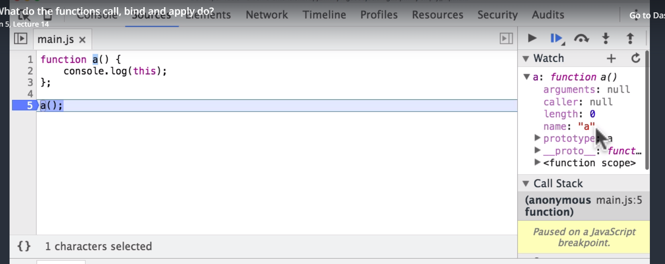
Length is the number of arguments passed to funcction.
we can even add our own properties to these functions.
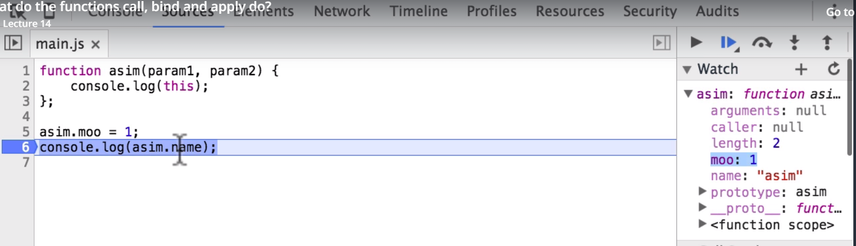
Here we have addded our own property moo to function asim. So we can treat functions as any other object. as other objects has some fucntions on them. Here also we have some fucntions. it will print actual content of function-
function sumit() {
console.log();
}

console.log(sumit.toString());

1)call-
asim.call()
asim is function. We can call it using .call. to call we can pass a parameter. Now this in function will refer to parameter that we pass to call function. We can pass empty object, then this will point to empty object. we can even pass a number to call, then this in fucntion will be number.
function asim() {
console.log(this);
}

asim.call(1);

Solution to problem in last lecture-
'use strict'
var asim = {
checkThis: function () {
function checkOther() {
console.log(this);
};
checkOther.call(asim); // now this is checkOther will point to asim
}
};
asim.checkThis();

So we use call to stabilize this function.
Asim() => Asim.call();
It means both are equivalent. If we are not using strict mode then in both cases this will point to window object. If we use strict mode then this will point to nothing.

What if our function takes parameters? Then to call first argument is what this should point to, the we pass function arguments. Ex-
Asim({},2,34,); // here first argument is what should this point to, followed by parameters of Asim function.
2)apply-
asim.apply(1,[2,3,4,])
it is similar to call, first parameter is what this should point to, then arguments to function are passed in array.
So whne do use apply and when use call. We use apply when we pass many arguments to function, instead of passing these paramneters one by one one we can pass the array. Array we pass to apply will be caught by arguments array in apply.
Ex-
function sum() {
var total = 0;
for (var i = 0; i < arguments.length; i++) {
total += arguments[i];
}
return total;
}
var things = [1, 2, 3, 4, 53, 4, 56, 1];
var x = sum.apply(null, things);
console.log(x);

3)Bind

So if I have to write a function expression ,then by using bind we can define what this will point to. We can do his when we define our function, that’s the difference.
Ex-
var a = function () {
console.log(this);
}.bind(1);
a(); // this wll point to 1, because we set it in this way

even if we do this-
var a = function () {
console.log(this);
}.bind(1);
a(); // this wll point to 1, because we set it in this way

var asim = {
func: a
};
asim.func(); // even now this will point to 1, because we set in function declaration

now we call function normally and our this will point to what we passed in bind at time of declaration.
One important thing to note is-
function a() {
console.log(this);
}.bind(1);

bind can only be used on functions after they have been created and assigned to a variable
This wnt work. We need to use function expressions if we want to use bind. Reason for this is bind can be tied to object only , and by using function expressions we are creating objects.
When we do this-
var a = function () {
console.log(this);
}.bind(1);
a(); // this wll point to 1, because we set it in this way

actually we are doing this-
var a = function () {
console.log(this);
};
a = a.bind(1);

read this article for diffrence between all 3 –
https://codeplanet.io/javascript-apply-vs-call-vs-bind/
16)What is Prototype Chain(Object.create)
See copy notes of prototype chain. Every js object has a prototype. In some browser which supports prototype, when you add object to watchlist, you can even see __proto__ property on them.
__proto__ is not part of standrad interface of javascript. Well not atleast ecmascript 6. So you should’nt use in production code. Herew e will just use it to explain the prototype chain.
See copy notes of javabarins.
animal.isPrototypeOf(asim), this will return true if,
asim.__proto__ = animal;
also rpeoprty lookup is dynamic, we will always get updated value-
var animal = {};
animal.name = 'dog';
var asim = {};
asim.__proto__ = animal;
console.log(asim.name);
animal.name = 'cat';
console.log(asim.name);

as we know that __proto__ property is not supported by many browsers(ES 6 supports it), so how to we setup prototype chan. –
var asim = Object.create(animal);
here animal is a object with properties.it means animal is prototype of asim. i. e it is equivalent to-
asim.__proto__ = animal.

var animal = {};
animal.name = 'dog';
// var asim = {};
// asim.__proto__ = animal;
var asim = Object.create(animal);
new line serves same purpose as commented line.
So it means by using create method we can set up prototypes of objects. Now we can also add properties to asim using Object.create.
var asim = Object.create(animal,{food:{value: ‘mango’}});
code-
var animal = {};
animal.name = 'dog';
// var asim = {food: 'mango'}
// asim.__proto__ = animal;
var asim = Object.create(animal, {food: {value: 'mango'}});
console.log(asim);

this will add property food to asim and value of this property will be mango. But if you run code in nodejs then asim object will be empty but if you run it in browser, it will have food proeprty.
Second parameter to object.create, is a object that describes the properties you want to add onto the created object. you are not passing a object to use as properties but you are passing in an object that describes the object.

17)Difference between prototypal and Classical Inheritance
Classical Inheritance- it is how inheritance works in c++/java. We have a class, then we create objects from it.i.e instances of classes
Prototypal Inheritance – it is how inheritance works in js. We create object from obects.
So if js is just prototype inheritanve, what do people mean when they say classical inheritance in js? what they mean by is there is method in js we have a method by which we can emulate classical inheritance . atleast it looks like it in code. It is some times called classical inheritance,some times construct pattern, sometimes Pseudo-Classical Pattern. Note that there is’nt real classical object oriented method in java script because all object orientation in js is based on prototypes.
So we have 2 methods to implement inheritance in js_-
Fake Classical pattern(Pseudo Classical pattern)
Direct Prototypal Pattern
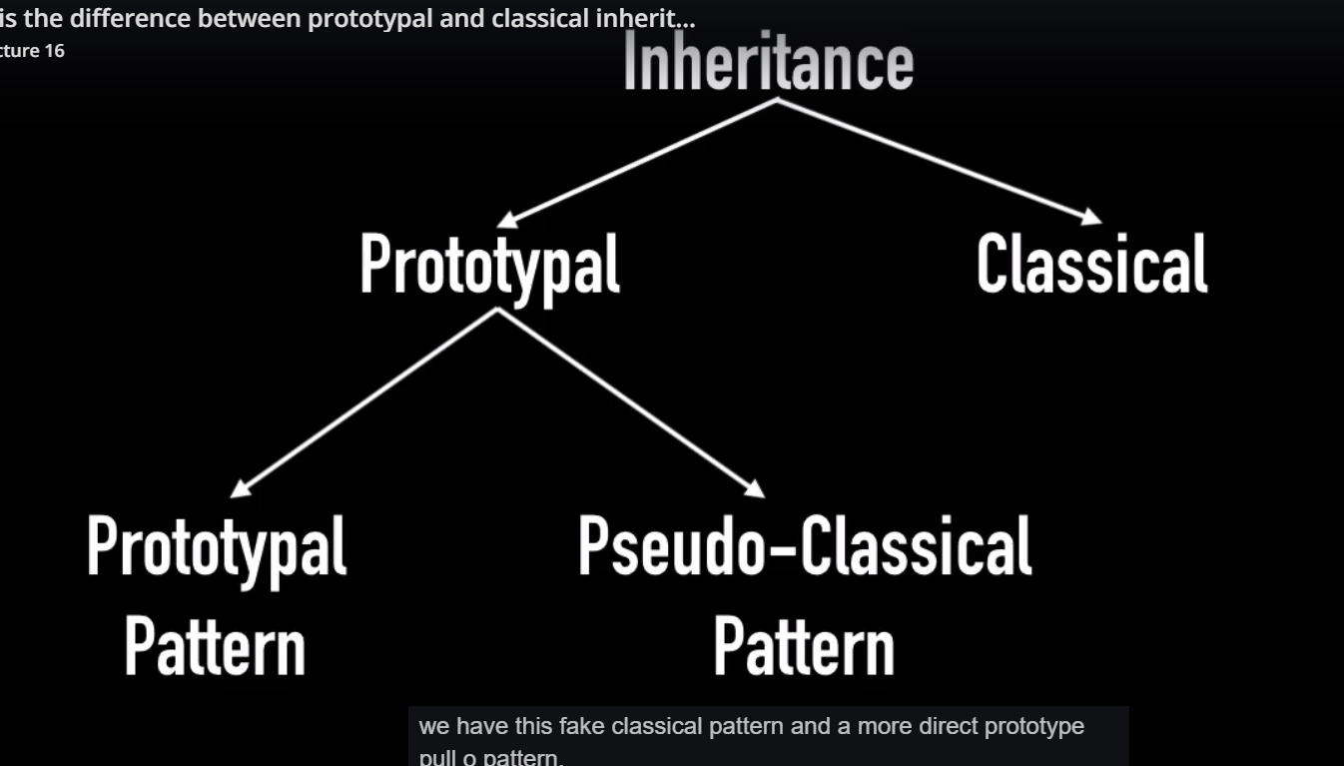
So classical pattern is faked in js.
To summarize we have 2 types of inheritance – classical and rotoypal. In js we only have second type. Again prorotypal inheritance in js is of 2 types, direct protoypal and psedo classical pattern. Pseudo classical pattern is a way of writing classes and writing functionality in js which would be similar to people who are coming from c , c++ and java.
18)What is constructor OO Pattern?(part 1)
Here we will create psedo class i.eFunctions in constructor mode
Here we will see how to implement pseudo classical inheritance in js. We will see how to implement psedo classical OO principle in js .object oriented programming and inheritance in js are really hard to learn. there are no core language features to support it. In es5 we don’t have classes but we have them in es6.. But we can mimic them in js by using function constructor and new keyword.
Here we saw how we can create object by calling functions in constructor mode.there we mimiced the classes.now we want to add functions to our class. There are 2 approaches . First is to define the property in function as we do with other property. Like-
function Employee(){
this.salary = 70, 000;
this.getSalary = function () {
return this.salary;
};
}
Second method is to add methods to the prototype of Employee Function.
Employee.prototype.getSalary = function () {
return this.salary
};
Advantage of second approach is that we are saving memory. All instances of object created , share this property.in first approach we add functions to each instance. In most cases we should use second approach.
But we have advantage in first approach. Which is here we can simulate a private member variable. To implement private variables do this-
function Employee(salary) {
this.getSalary = function () {
return salary;
};
}
var emp1 = new Employee(8000);
emp1.getSalary();

this behavior is possible only because of Closure in js. As we return this in Employee function, salary variable is accesible because of closures. Now we cnt access salary because it is in function scope. But it can be accessed via getSalary function because of closures.
So here we implemented psedo classes and pseudo private variables in those classes.
19)What is constructor OO Pattern?(Part 2)
In last lecture we saw that how we can have have psedo variables by calling functions in constructor mode. here we will see how do we implement inheritance in psedo classical patern or constructor pattern.
Ex-
function Person(first_name, last_name) {
this.first_name = fisrt_name;
this.last_name = last_name;
};

Person.prototype.full_name = function () {
return this.first_name + ' ' + this.last_name;
};
function Professional(honorific, first_name, last_name) {
Person.call(this, first_name, last_name);
this.honorific = hororific;
};
Professional.prtotype = Object.create(Person.prototype); // we have inheritance because of this line.
Professional.prototype.professional_name = function () {
return this.honorific + ' ' + this.first_name + ' '+ this.last_name;
}
var prof = new Professional('Dr', 'Asim', 'Khan');
console.log(prof.professional_name());
console.log(prof.full_name());

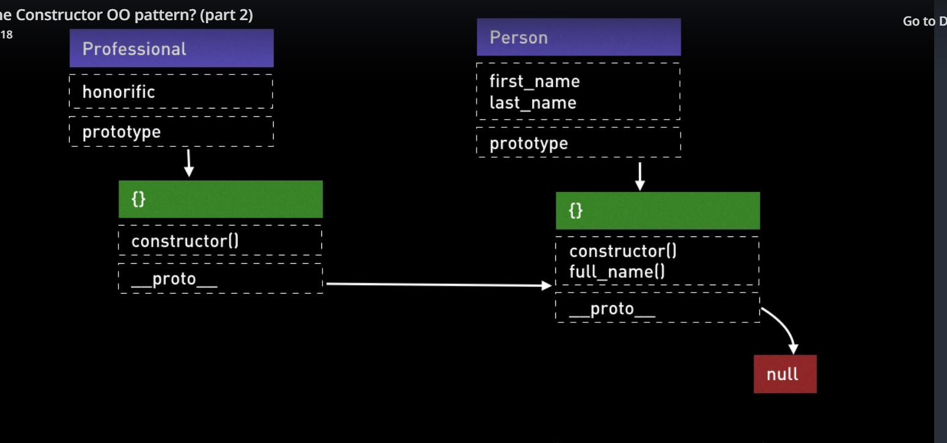
So we end up creating something like this-
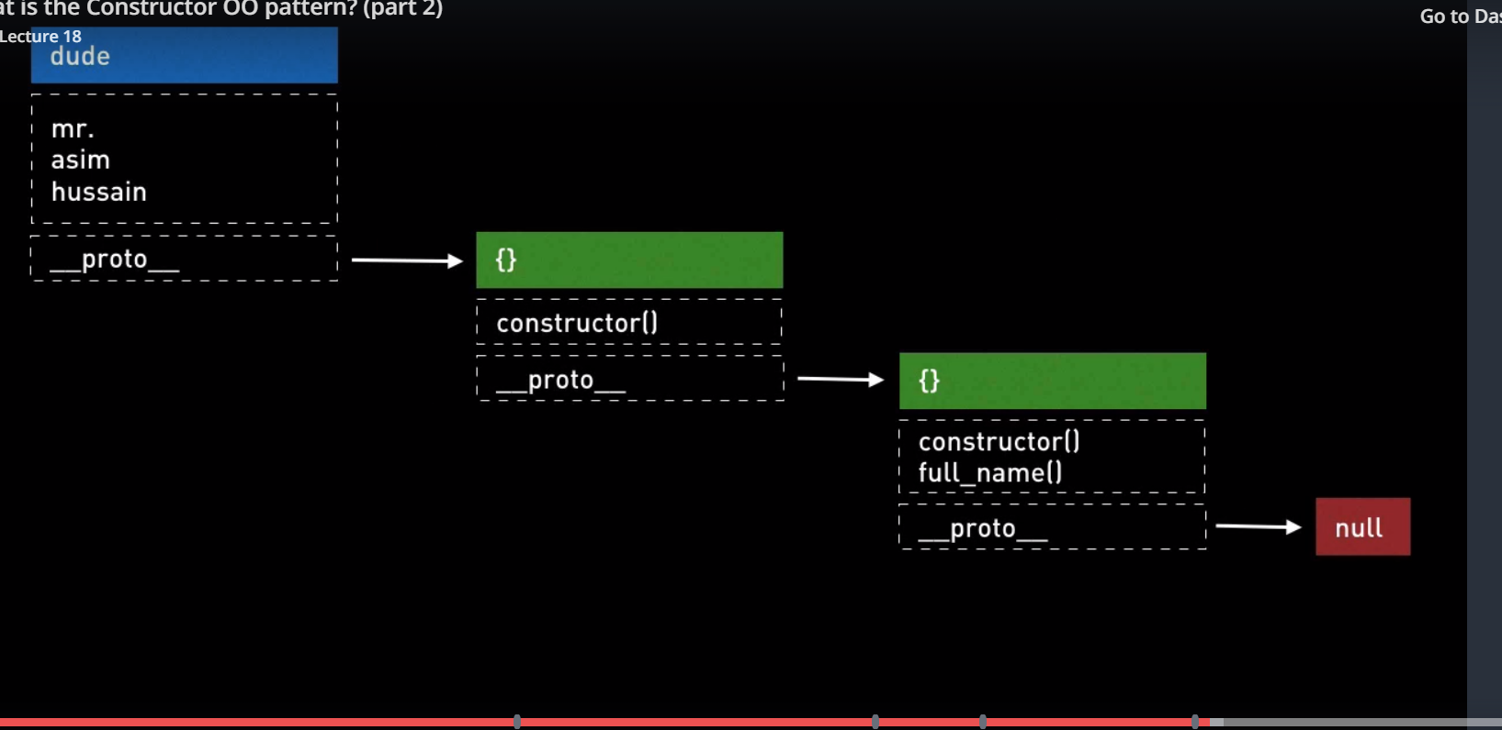
Here person is our Parent class and Professional is our child class. We can implement inheritance if prototype of professional functions points to prototype of person function.we can do it via this-
Professional.prtotype = Object.create(Person.prototype);
What this has done, see figures.
Here what we are doing is- first we recreated prototype of Professional. Then we made __proto__ property of it point to Person’s prototype. When we call any function on prof, first it will look on itself, then it will look on its protype, then it will look on prototype of its protype.

20)What is ProtoType OO Pattern?
In last lecture we saw OO pseudo inheritance(classical inheritance). Here we will see prototype inheritance pattern. It is lot easier. It is just prototype chain. Here we dnt create psedo class(function in constructor mode). We basically say, create a object whose prototype is this other object and also please built this object with some new properties. Advantage of this approach is , here we are working with tools that java script supports natively rather than attempting to imitate features of other language. Ex-
var Person ={
full_name: function(){
return this.first_name + ' ' + this.last_name;
}
};
var asim = Object.create(Person);

Person is our base object , we then built another object whose prototype points to this base person object. Now __proto__ property of asim points to Person. So now asim can access properties on Person object. We can call full_name function on asim. Now problem is that we dnt have properties on our asim object. In last approach we added them to this keyword.
Here we will see couple of approaches-
1)first approach is , we use a function in base object to do so.
var Person = {
init: function (first_name, last_name) {
this.first_name = first_name;
this.last_name = last_name;
return this;
},
full_name: function () {
return this.first_name + “ ” + this.last_name;
}
};
var asim = Object.create(Person);
asim.init(“asim”, ”hussain”);
conslole.log(asim.full_name);

2) SECOND Method is to use second argument to create function. Second parameter is object which describes the properties that we want on asim object.first_name property expects a object. Now in this object we can define not only value we can also define some other things, like whether it is read or write, is it enurmable etc.
var Person = {
full_name: function () {
return this.first_name + “ ” + this.last_name;
}
};
var asim = Object.create(Person, {
first_name: { value: ‘Asim’ },
last_name: { value: ‘Hussain’ }
});
console.log(asim.full_name);

second approach is very verbose. So third solution is preffred.
3) here we create a another function named PersonFactory. Factory is a function that just returns a Object.
var Person = {
full_name: function () {
return this.first_name + '' + this.last_name;
}
};
function PersonFactory(first_name, last_name) {
var person = Object.create(Person);
person.first_name = first_name;
person.last_name = last_name;
return person
}

var asim = PersonFactory('asim', 'hussain');
console.log(asim.full_name);

we saw 3 approaches, it is personal choice which one we want to use. So we covered how to create instances of objects which point to other objects via that prototype approach.
the question is how to do we inherit? With prototype method , there is’nt any specific inheritance methodology. We just keep on adding to prototype chain. Lets say we want a Professional class and we want it to inherit from Person as we did in last lecture.
var Person = {
full_name: function () {
return this.first_name + ' ' + this.last_name;
}
};
var Professional = Object.create(Person, , {
professional_name: {
value: function () {
return this.honoric + ' ' +this.first_name + ' '+ this.last_name;
}
}
});
var asim = Object.create(Profesional);
console.log(asim.full_name());
console.log(asim.professional_name());

now all we have to do here is to add properties to professional object or asim object. We can do that by approaches already covered. One way is to add a init function to professional. We can also create a professionalFactory function.
So this is prototypr pattern.we are just connecting objects to objects via prototype chain.
You might be asked in interview when will you use pseudo classical or constructor pattern , and when you will use prototype pattern? Both are common. Both are widely used. They have advantages and disadvantages-
Pro of constructor pattern-
1)By far it is most common.its written everywhere. So you should know it. So that you can recognize code written in this pattern.
2)we can private variables, prototypes approach does’nt support this feature.
3) this is similar to languages like, java,c++ etc.

Pro’s of prototype pattern-
1)Very easy to understand

You can use any one of 2 the but it is necessary to know about both of them.
here asim points to professional, professional points to person. So that’s it that’s how you do inheritance in prototype pattern.

21)What is CORS
CORS stands for cross origin resource sharing. CORS allows you to break same origin policy of browser. Lets see this policy-
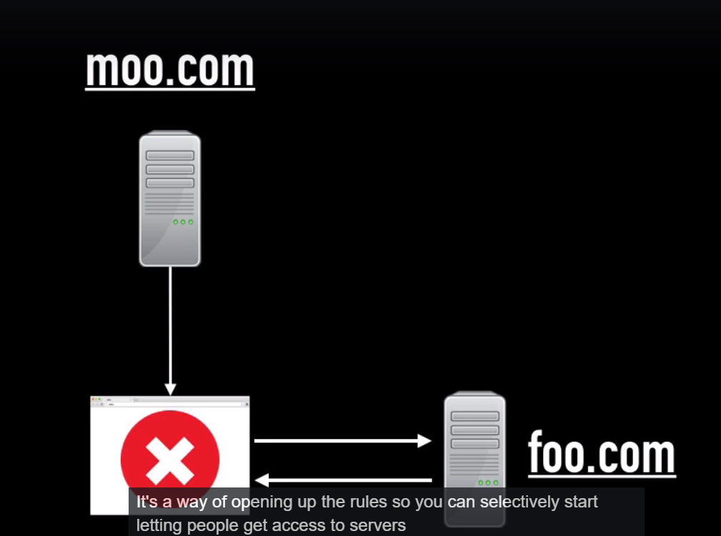
Lets imagine that you go to moo.com and you load the web page from moo.com and within that web page came html, css and js. when js when ran it request some data from foo.com, perhaps foo.com is a rest api. So it send request to foo.com and then foo.com does its processing and sends a response but the same origin policy means that by default any further requests that need to be made for additional resources they must only come from or be sent to moo.com. so because js requested some data from foo.com, when data is returned it’s blocked by browser. So browser does’nt let that data propagate into rest of your js code in your application. That is same origin policy of browsers and reason it exists is, because it is security feature.
Lets say your own foo.come and for foo.com you created an api to support the running of own website. Somebody else at moo.com, some unscrupulous developer decided , hey I cnt be bothered to create my own api, I am going to use one that I found on foo.com instead. So what they do, they dnt even contact you, they just secretly write some js code on their website and somone visists it, they show data from foo.com. so same origin policy prevents same from happening. It blocks it at browser level and its security feature. It is what it does by defalut. CORS, cross origin sharing is mechanism that lets you selectively unblock certain requests, for example in this scenario, if foo and moo are owned by same person, they might want to setup CORS, so that their website could request data from foo.com. so that is what CORS does. It’s a way of opening up the rules so you can selectively start letting people get access to servers from different origins.
So how does it happen? Consider above case. By default our website can’t access data from foo.com. but if we want to open up the access, there are 2 ways in which it can happen. 2 high level ways in which it can happen.
Now the first one I am going to show is with normal basic get request because that’s the simplest to understand and the other requests are actually based upon same logic as the get requests. But with few more fetaures.
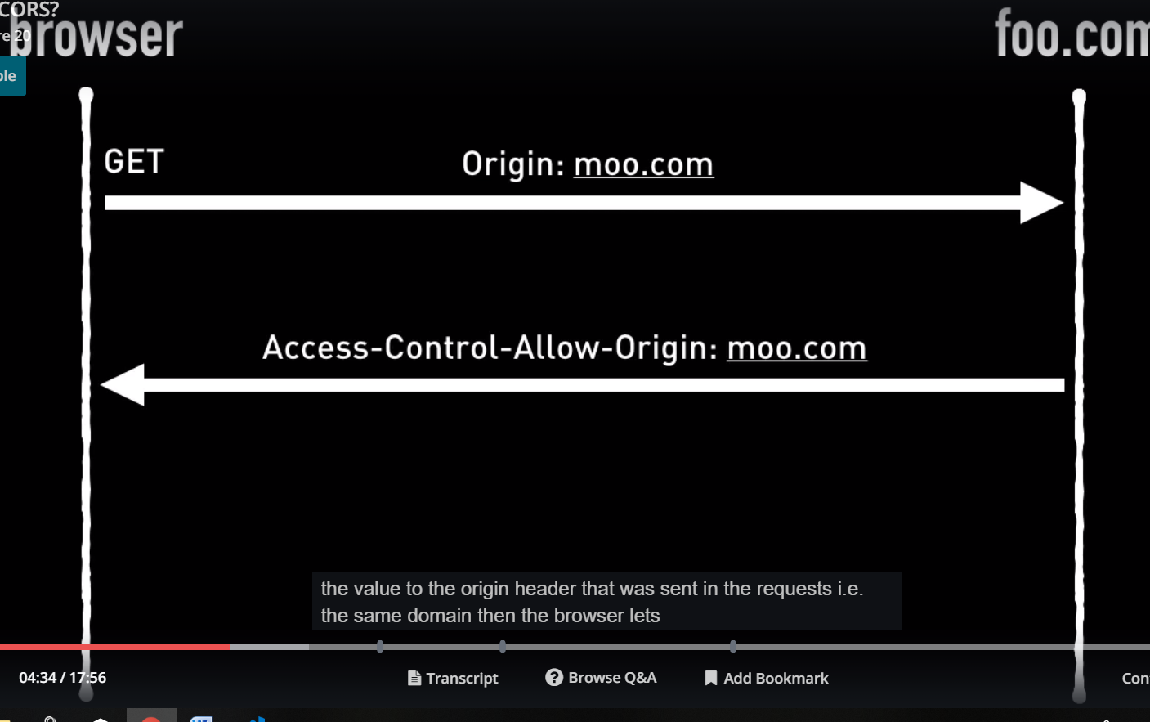
So browser sends a get requests. In headers to that http requests browser adds origin. So origin is the domain whose website browser is currently displaying. Currently we are displaying data from moo.com, so origin will be moo.com. requests reaches server it do whatever it needs to do and for CORS to take effect, the response has to have the header aceess control allow origin and if value to that headers is moo.com or I should say it is same as value of origin headers in request. The browser allows that response to proppagate through your application and basically pass it to js code
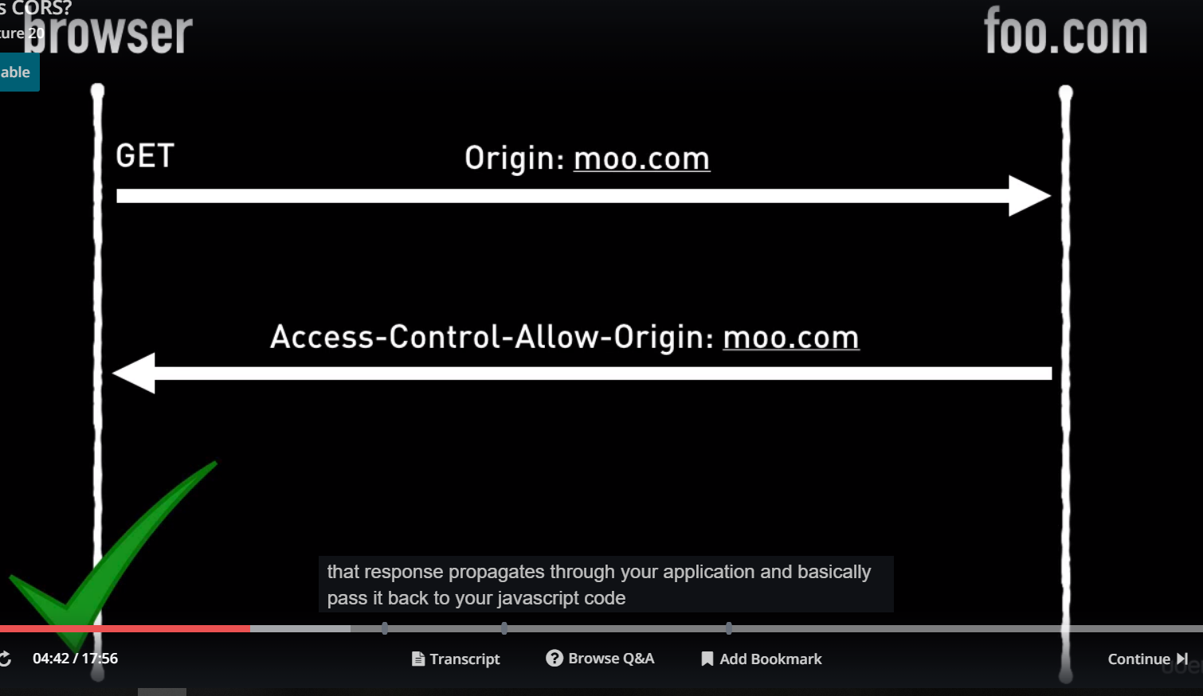
Now server can also pass back a star(value of header access-control-allow-origin). I means I dnt care who uses my api, everyone can use my api.
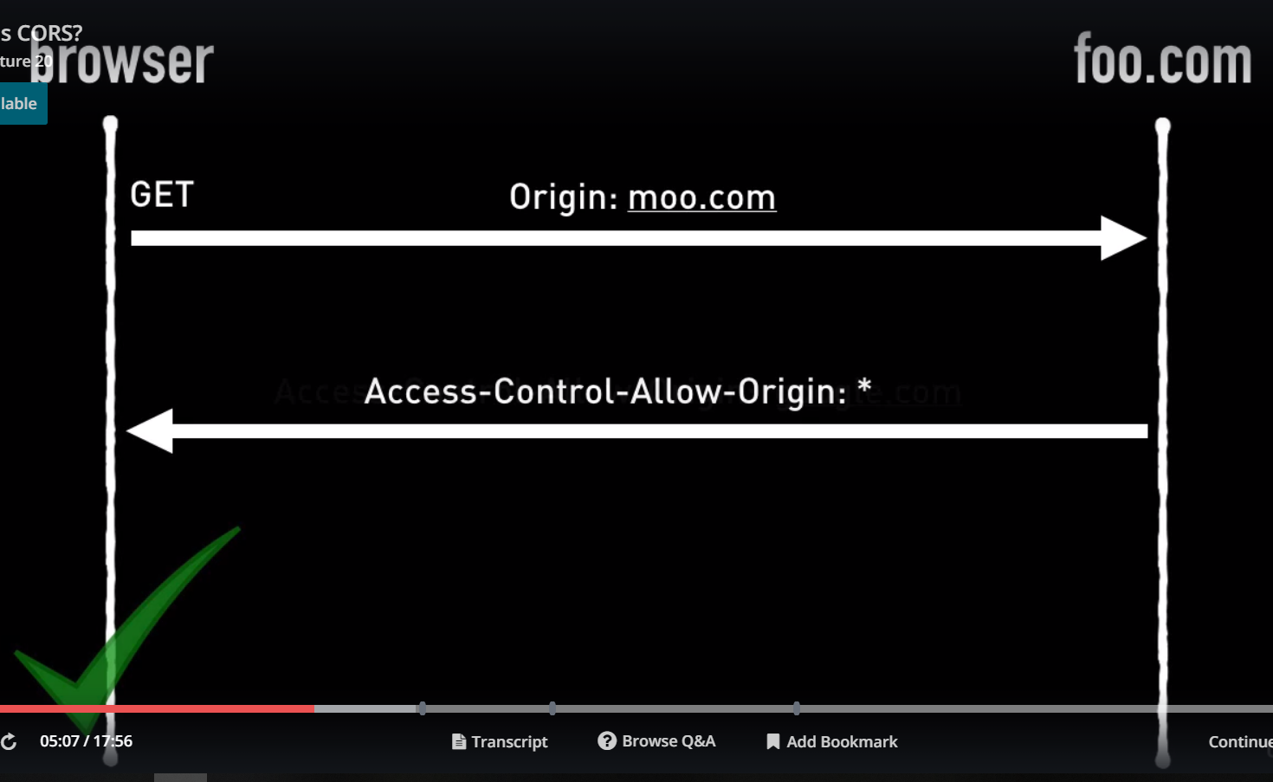
However if value of that header is something else, browser blocks that response from propagating through rest of your application.
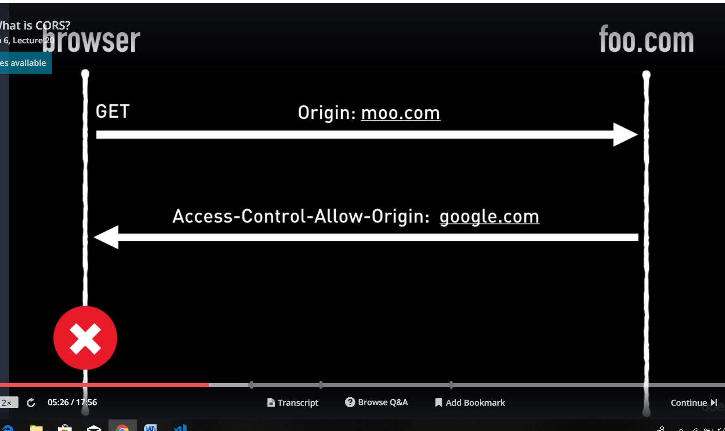
You js code wnt even see that response.
So summarize, to enable croos origin resource sharing, the browser will always send the origin header to server when sending a get request and expects the server to respond back with a header called Access-Control-Allow-Origin , whose value is either same as origin domain that was sent in requests or *. Anyother value or if Access-Control-Allow-Origin is not present in reposne, that will cause the browser to block that response from propagating through rest of your app. it is response that is block, many candidates say that request is blocked. And that is super important to know because it explains why we do it sligtly diffrently for put, post and delete requests.
Lets say posts works in same way as get. Then server has made chnages on its database, file syste etc. and its sends a response and that response is blocked by browser. Now it is of no use, because server has already made changes to its database. So how CORS gets around this by sending something called a pre-flight requests. So pre-flight request is basically a http requests of type with method options. So if we are sending a put requests, the first thing the browser will do is actually to send a options request to foo.com, it will have 2 headers, as shown in figure beow. Here browser is basically asking foo.com, hey look I want to send youa put request and this is kind of data I am going t send in put. Is it allowed? Is it ok? Then foo.com sends a response with headers as shown in figure below. First header an be * or what was sent in origin header of requests. Second header can contain comma separated list of http methods like put,post,delete or it may have one method. But it atleast contain the same method that’s been requests in the request.
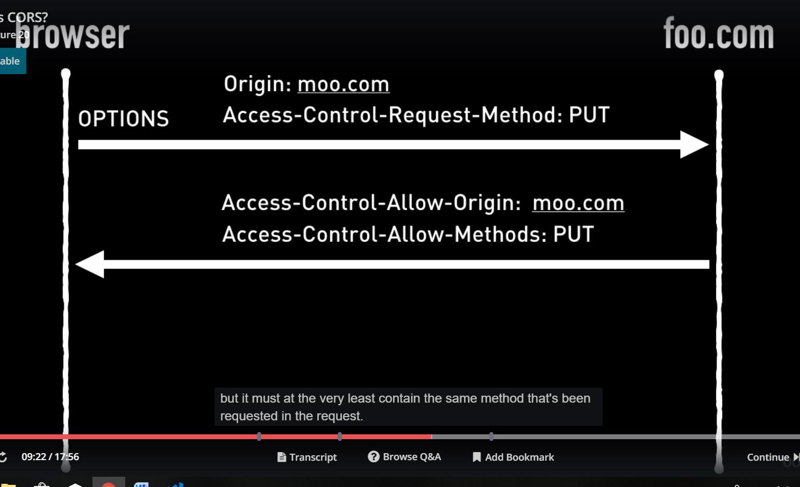
So if browser see it has reposne has put method in second header and domain in first, then it continues. In any other case(value of headers in not correct or headers are not present) browser will block response and it would’nt issue a put request.
But if everything is ok at this point, if this pre flight little test handshake request got response succesfully, only then borwser will issue the put requests. At from this point forward it is very similar to get request that I showed you previously. That is browser wills send origin headers, server will do its work and send back reposne with headers shown in figure, now if value of headr in response is * or same as that of origin header in request, your js code will get the response. See figure- 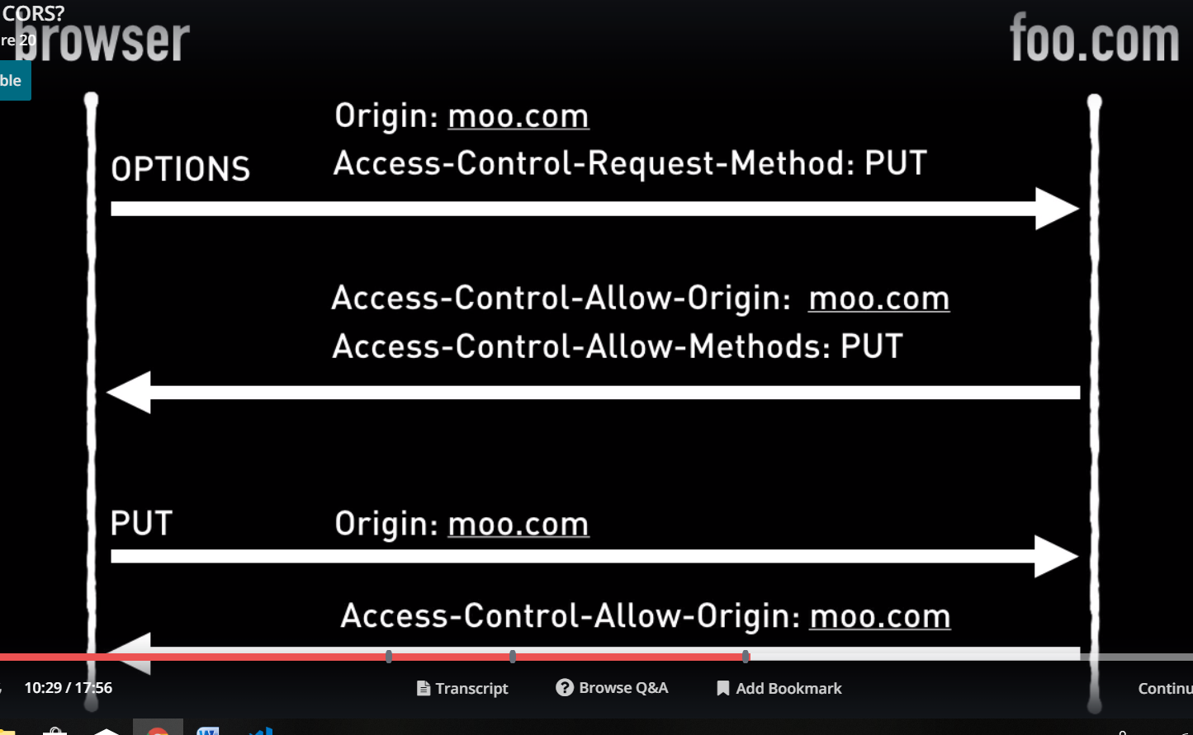
Lets actually go throgh coule of examples using tools on the internet. Go to-
https://www.test-cors.org/
this website acts as both client and server and it lets you test out requests being sent, you can change the server setting as well, so you can see how different responses cause different effects in the browser.
Lets send a get request. Uncheck the cors checkbox on server side. In console, you can see error.
No 'Access-Control-Allow-Origin' header is present on the requested resource
In network tab you can see that resposne status is 200, so everything went well on server side, it was our browser who blocked the requests. Now lets see hedaers of request and response. You can see that request has origin header but response does not have any required hedaers(see hwat should be there in get requests). That is why browser is blocking this.
If you click on CORS checkbox on server side, you can see that resposne has required headers and there is no error on console.
Now lets try put requests. In this case cors options is set. When we send request we see errr in console. –
Method PUT is not allowed by Access-Control-Allow-Methods in preflight response
If you open network tab you can see that we are sending one http request, method is options , that is why I explained before this pre flight request. status is 200. Now in request we can see 2 headers, as explained in slide. Now in response we can see that first headers is there, this is because CORS checkbox is checked. But second header is missing. So browsers does not sends the orignal post request. That is why you see only one request in network tab.
To correct this on server side, fill PUT in allow methods text box. Now you can see that all required headers are there and we see 2 request in networks tab. First one is options request and second one is put requests. Second request and response have same headers we would have in normal get requests(i.e both requets and response have headers as shown in get request).
There is more about CORS. I will leave some links if you want to dive deeper. But for interview purpose this is enough. There are books written on it. If you see CORS error and you dnt have access to server, there is nothing you can do.

22)Whats is JSONp
See lecture
23)Diffrence b/w event bubbling and event capturing
Code-
<body class="body item">
<div class="first item">
<div class="second item">
<div class="third item">
<button class="fourth item">Click Me!</button>
</div>
</div>
</div>
</body>

Now our browser prepares DOM from html.
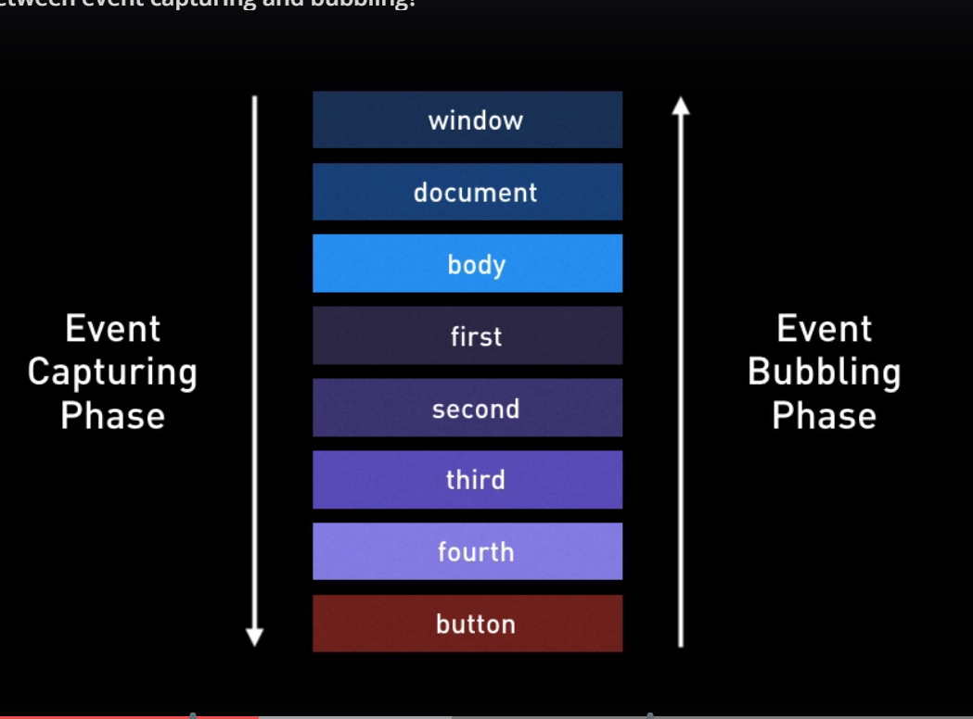
So what will happen when we click on button. see figure .Root object(window in case of browser) fires an event and it travels down the tree to button. the button is what we call the target. Althrough the event goes to target it also touches every single parent of button on the way down. So if you have added event listeners for click event to any parent elements of button, they will be called. When this event reaches the bottom to the button, it again travels to top of stack, to root object. So it does’nt matter where you click on page, event always starts from root goes to target and then backup to the root again.these 2 arrows in figures are called phases.
Part that goes from root to target is called Event Capturing phase or phase 1, second one that goes from target to root is called Event bubbling phase or phase 2.
So all elemnts on path will get notified twice when an event is fired. So why have’nt we seen evidence of that in our code? According to this theory every event listener we have added to code should get called twice but In code our all event listeners get called only once.
This is because when we add event listener we can specify which phase we want to listen. We dnt specify anything then by default it will listen to event bubbling phase.so where we do define it-
items[y].addEventListener("click", function (event) {
console.log(items[y], event);
}, false);

we define it in third parameter to addEventListener, it is boolean.if we dnt specify it then it is going to be bubbling phase.if we specify it as false then again it is for bubbling phase.if it is true, then it is capturing phase.
Lets add some code to html-
var items = document.getElementsByClassName("item");
for (var i =0; i< items.length; i++) {
(function () {
var y = i;
items[y].addEventListener('click', (event) => {
console.log(items[y], event);
}, false);
}) ();
}

see code. we used IIFE so that we can have closure. we used closure so that when we are printing the element on which event occured, we are printing the right element.
execute code, to see how events are called. change third argument to true and false to execute these events to be executed on bubbling and capturing phase.
so to summaarize when you click on something it's actually 2 pahses that event travels through-
First phase is capturing phase and event travels from the roots to target
Second is bubbling phase and event travels from root to target. we can add event listeners which listen to those 2 phases independently.
true- capturing phase
false - bubblong phase
not specified - false

24)diffrence btw stopPropagation and preventDefault
this is followon question after previous question on events.
stopPropagation
stopProgation actually stops the event from either proceeding down the event capturing phase or going up the bubbling phase. no listeners will be called after the events has been told to stop propagating.
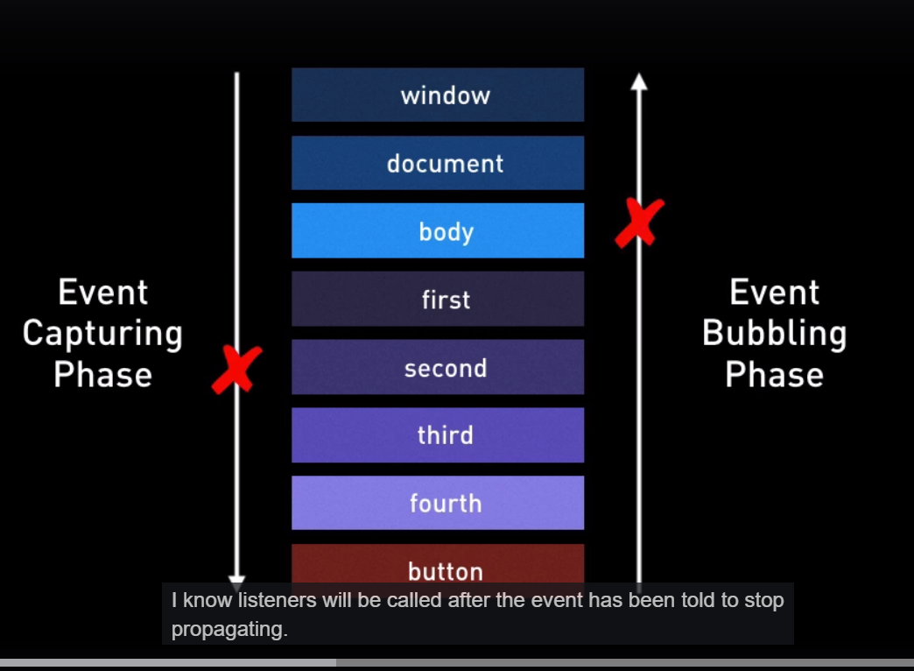
see your code.
Html code-
<body class="body item">
<div class="first item">
<div class="second item">
<div class="third item">
<input type="checkbox" class="fourth item">Hello<br>
</div>
</div>
</div>
</body>
Js code-
var items = document.getElementsByClassName("item");
for (var i =0; i< items.length; i++) {
(function () {
var y = i;
items[y].addEventListener('click', (event) => {
alert(y);
console.log(items[y], event);
}, true);
}) ();
}

here we added a checkbox instead of button and we are added a alert in event listener . purpose of alert is to to show that event does'nt propogate, i.e event does'nt move to next listener untill previous listener is finished. when we click on ok in alert only then event moves to next listener. when we do then next alert comes and so on. so that is first thing to understand as it is propagating it is not asynchronous. the next event listenet won't be called untill previous event listener has finished executing. Now lest change code-
var items = document.getElementsByClassName("item");
for (var i =0; i< items.length; i++) {
(function () {
var y = i;
items[y].addEventListener('click', (event) => {
if (y ===2) {
event.stopPropagation();
}
alert(y);
console.log(items[y], event);
}, false);
}) ();
}

now in code we added event.stopPropagation(); to stop event propagation. same can be used in event bubbling. After event is on y ==2, it does not travel further. So that is what event.stopPropagation does. Same thing can be done in bubbling phase.

preventDefault
in our loop lets call event.preventDefault for all elment. now preventDefault does'nt stop event from propagating , event propagates as expected. but now checkbox is not clicked. if we dnt use it then checkbox was clicked. so checkbox is not clicked but event goes through it's full path. App.js-
var items = document.getElementsByClassName("item");
for (var i =0; i< items.length; i++) {
(function () {
var y = i;
items[y].addEventListener('click', (event) => {
event.preventDefault();
alert(y);
console.log(items[y], event);
}, false);
}) ();
}

so stopPropagation stops the evnt from actually propagating, from moving to next elemnt.preventDefault stops the default behaviour that event would have triggered in whatver elemnt you perform the event on. so for checkbox it will prevent the tick being applied on checkbox.

